**Report on Intra-College National Anthem Singing, Painting, Seminar, Essay Writing Competitions**

In connection with the 79th National Independence Day Celebrations, Govt. Degree College Kupwara conducted intra-college National Anthem Singing **Painting,Seminar, Essay Writing Competitions** today on on 05th of August 2025. Students from different semesters participated in the events. The events were organized to foster unity and pride among the participants and audience.

For National Anthem Singing Competition participants were evaluated based on vocal quality, emotional expression, stage presence, and overall performance. Each element was meticulously considered to ensure a comprehensive assessment of their abilities and artistic delivery. Sheeraz Ahmad Lone (5th Semester) and Khair-ul- Nisa (5th Semester) secured 1st and2nd positions respectively.

Painting Competition on the theme ‘Portraits of Unsung Heroes of Indian Independence’ was organized. In the competition Sadiya Shabir from 3rd semester, Toufeeq Farooq from 5th semester secured1st, 2nd positions respectively. 3rd position was shared by Asif Bashir and Sumaila Idrees from 3rd semester

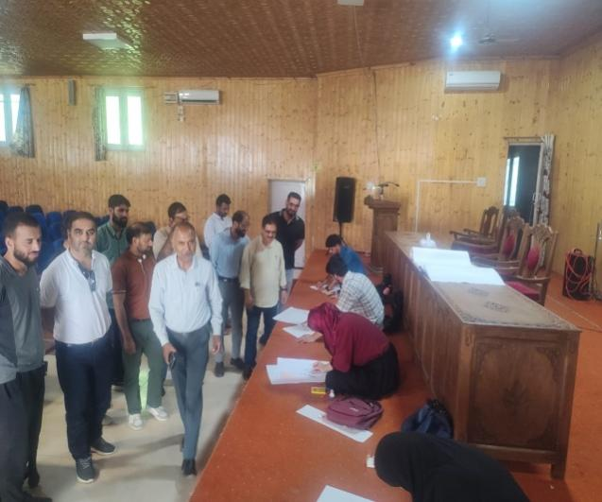 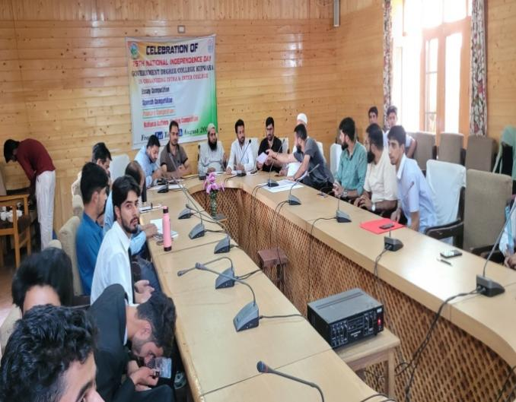

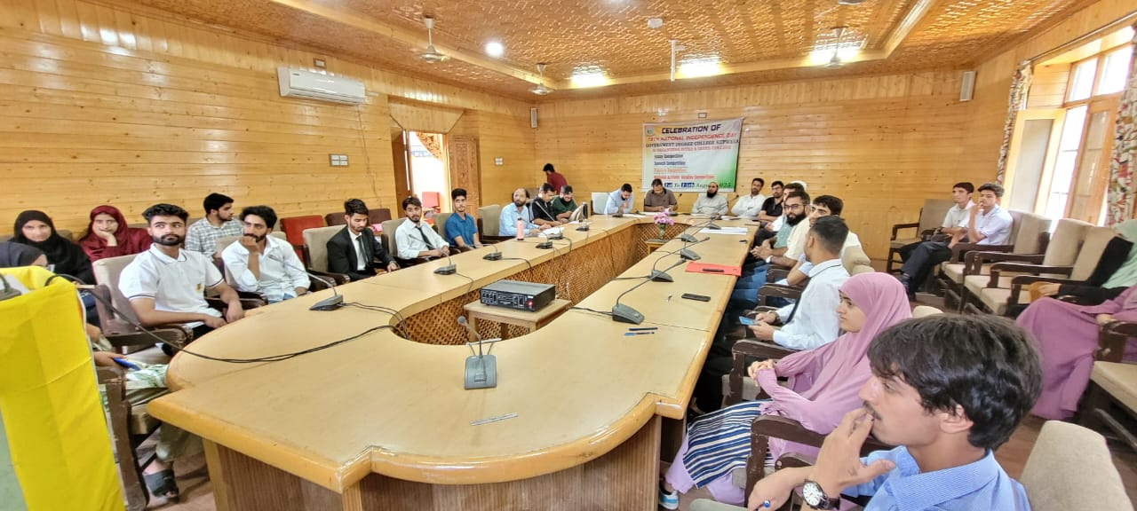

Speech Competition on the theme ‘Role of J &K Youth in Achieving Viksit Bharat @2047’ was also organized in which Naveed-Ul- Islam from 3rd semester and Abdul Lateef Bhat from 3rd semester secured 1st and 2nd positions respectively and the 3rd position was shared by Mohammad Saleem Wani from 3rd semester and Shariq Gani Lone from 5th semester.

The theme of the Essay Writing Competition was ‘Role of Education in Promoting Peace and National Unity’. Syed Aqib Andrabi from 3rd semester, Kaisar Manzoor Pir from 3rd semester and Pirzada Faizan Altaf Shah from 5th semester secured 1ST, 2ND and 3rd positions respectively.

Worthy Principal Prof. (Dr) Abdul Rashid Malik in his presidential Adress appreciated the students for showing interest in the activities holding importance in the history of nation. He expressed his view that these competitions are significant as they instill the sense of national unity among one and all. The proceedings of the programme were conducted by Prof. Mohammad Abass Bhat, Head Department of Environment Science.

The Competition was a resounding success, showcasing the talent and patriotism of the participants.

The competition culminated with the formal Vote of Thanks presented by Dr. Mohammad Yousf Wani, Head Department of Urdu.

SD-Media coordinator

Sd- Principal